Pull Request and Merge Request
# Source: AI Source: Provided by: [Data Path: Persons Table -> ID Column: 1, Name_En Column: Motasem Essam] -> From: [ChatGPT] on [2/15/2026]
Pull Request and Merge Request in the context of Git and version control workflows—these usually mean:

1. PRS – Pull Request (sometimes written PR)
# Source: AI Source: Provided by: [Data Path: Persons Table -> ID Column: 1, Name_En Column: Motasem Essam] -> From: [ChatGPT] on [2/15/2026]
Definition: A Pull Request (PR) is a way to propose your changes from one branch or fork to be merged into another branch or repository, usually the original project.
Key points:
- Used in collaborative projects, especially open-source.
- Lets maintainers review your changes before merging.
- Often includes comments, discussion, and automated checks (CI/CD).
Example:
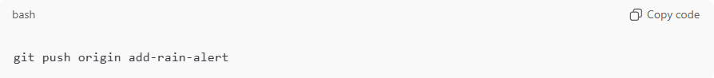
- You forked OriginalUser/WeatherApp, added a feature, and pushed it to your fork:
git push origin add-rain-alert
- On GitHub, you open a Pull Request from YourUser/add-rain-alert to OriginalUser/main.
- Maintainers review and merge if approved.
Explanation: PR = “Submit your work for review and integration”.

2. MRS – Merge Request (mostly GitLab terminology)
# Source: AI Source: Provided by: [Data Path: Persons Table -> ID Column: 1, Name_En Column: Motasem Essam] -> From: [ChatGPT] on [2/15/2026]
Definition: A Merge Request (MR) is essentially the same as a Pull Request but is the term used in GitLab.
Key points:
- Proposes that changes in one branch or fork be merged into another.
- Supports review, comments, and CI/CD pipelines.
Example:
- On GitLab, you have a fork YourUser/Project and created a branch feature-login.
- You open a Merge Request to merge feature-login into OriginalUser/Project/main.
Explanation: MR = “Request to merge your branch into another”, just like PR but in GitLab.

Quick Comparison
# Source: AI Source: Provided by: [Data Path: Persons Table -> ID Column: 1, Name_En Column: Motasem Essam] -> From: [ChatGPT] on [2/15/2026]
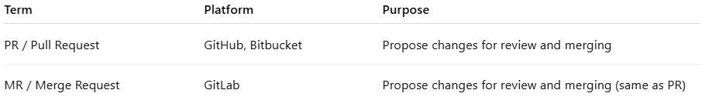
Term | Platform | Purpose
PR / Pull Request | GitHub, Bitbucket | Propose changes for review and merging
MR / Merge Request | GitLab | Propose changes for review and merging (same as PR)

💡 Analogy:
# Source: AI Source: Provided by: [Data Path: Persons Table -> ID Column: 1, Name_En Column: Motasem Essam] -> From: [ChatGPT] on [2/15/2026]
- Think of PR/MR as sending your homework to the teacher. The teacher reviews it, gives feedback, and accepts it into the main gradebook.

